**Rayman Legends:**

Challenges: 2D/3D blend, level depending moving parts and boards

**Full GamePlay:**

<https://www.youtube.com/watch?v=thQijhlRHQU>

**Potential Basic Scenes/Stages:**

* **2,000 Lums Under the Sea (Gloo Gloo):** Prop heavy, good motion in the background.

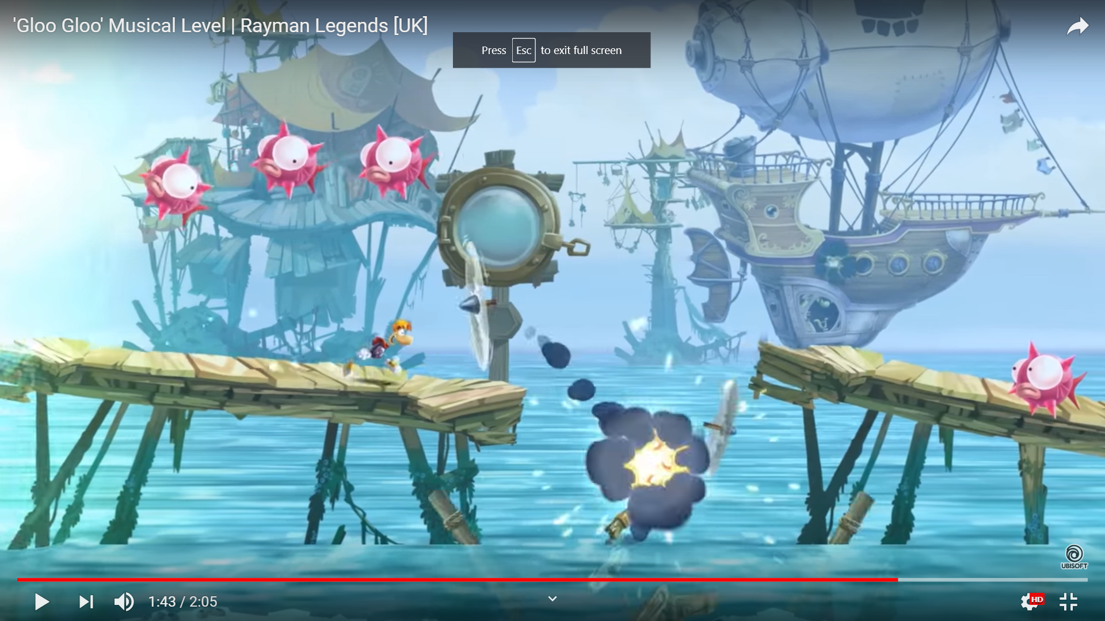

<https://www.youtube.com/watch?v=E7TRB8gka-4>

* **Great Lava Pursuit:** FX heavy (Fire), includes stone (difficult material), Cool lighting

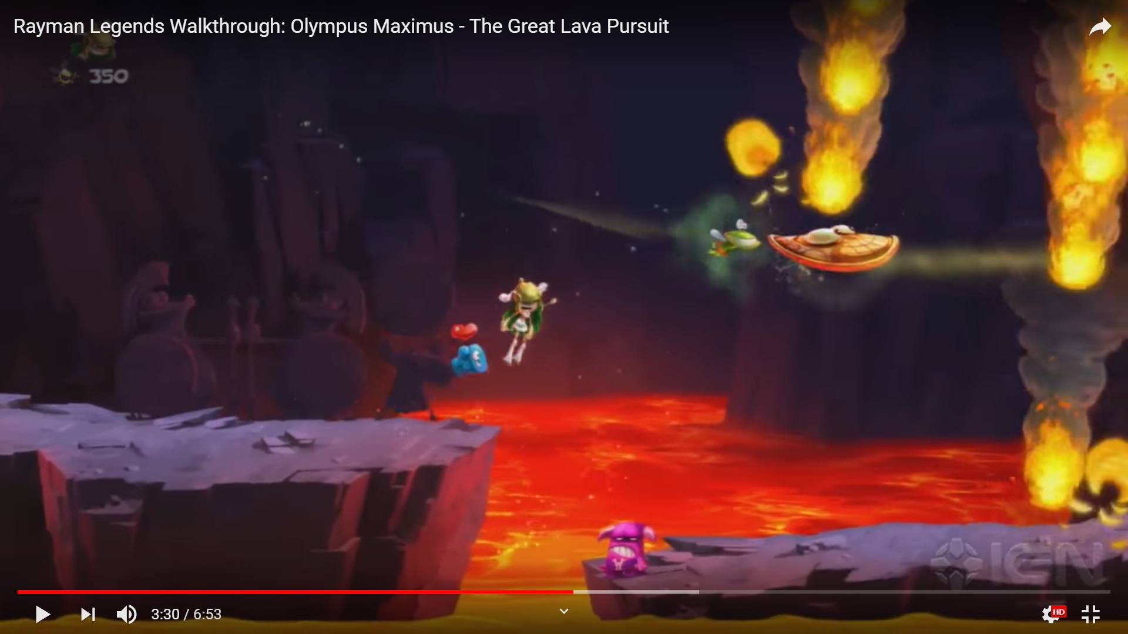

<https://www.youtube.com/watch?v=vQEoDgou-qw>

**Boss Levels:**

<https://www.youtube.com/watch?v=WzbBXpDppbg>

**Dragon and Water:** Could add motion and Steam to the Dragon, plenty of props in the background to deal with. Excellent Lighting.

